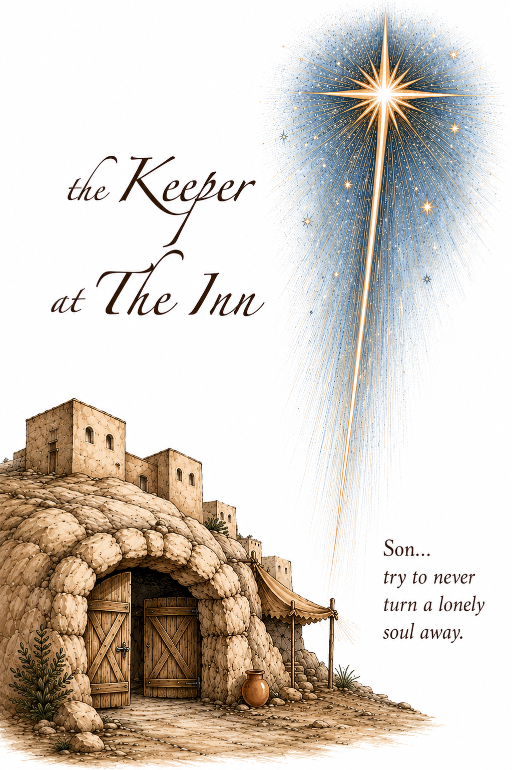
About The Author
Steve McCurdy is an author, playwright, filmmaker - and a Dad. When his children came home talking about the "mean old innkeeper" his heart went out to the old fellow and he thought... "What if he gave them his favorite place in his whole world?" And for 25 years he told the story on Christmas Eve to children and parents. The book came with the insistence is first grandchild's grandmother. And now... you have it, too.

The Composer
Ken Medema is one of the most creative and authentic artists performing today. He is a Christ follower with a passion for social justice. Uniquely, he is also blind. A wonderful spirit and performer - Ken jumped at the chance to create Jaiphus' world in music.
The Artist
Stephanie Lohmann was a student
in Steve's High School show choir
studying art in college. She created the world of Jaiphus and his family during FINALS her first semester!

Upcoming Events at ---

The Keeper at the Inn
The untold story of an innkeeper...
and the choice that changed everything
Prelude Christmas selections
Opening Hymn Away in a Manger
Lyrics on next page
Welcome Officiant
The Keeper at the Inn Follow along in your books
(The Video Guide)
Congregational Hymn (stop after Page 34) Silent Night
Lyrics on next page
Congregational Hymn After Video Joy To The World
Lyrics on next page
Closing Reflection Pastor
Benediction
",, and my father said, Son, remember -
Try to never turn a lonely soul away."

Away in a Manger
Away in a manger,
No crib for a bed
The little Lord Jesus
Laid down His sweet head
The stars in the bright sky
Looked down where He lay
The little Lord Jesus
Asleep on the hay
The cattle are lowing
The Baby awakes
But little Lord Jesus
No crying He makes
I love You, Lord Jesus
Look down from the sky
And stay by my cradle
Until morning is nigh
Be near me, Lord Jesus
I ask You to stay
Close by me forever
And love me I pray
Bless all the dear children
In Your tender care
And fit us for heaven
To live with You there

Silent Night
Silent night, holy night,
Silent night, holy night,
All is calm, all is bright.
Round yon virgin, Mother and Child.
Holy infant, so tender and mild.
Sleep in heavenly peace.
Sleep in heavenly peace.
Silent night, holy night,
Shepherds quake at the sight.
Glories stream from heaven afar
Heavenly hosts sing Alleluia
Christ the savior it born.
Christ the savior it born.
Silent night, holy night,
Silent night, holy night,
Son of God. Love's pure light.
Radiant beams from Thy holy face
With the dawn of redeeming grace,
Jesus Lord, at thy birth
Jesus Lord, at thy birth
Silent night, holy night,
Son of God - Love's pure light.
Radiant beams from Thy holy face
With the dawn of redeeming grace
Jesus Lord, at Thy birth.
Jesus Lord, at Thy birth.

Joy To The World
Joy to the world, the Lord is come - Let Earth receive her king.
Let ev'ry heart, prepare Him room - and Heaven and Nature sing.(3)
He rules the world with Truth and Grace, and makes the nations prove...
The glories of His Righteousness - and wonders of His love (3)

